LB GLOBAL MEDIA — WEBSITE STRUCTURE & STRATEGY
(3 Core Pages)

PAGE 1 — HOME / ABOUT US

LB GLOBAL MEDIA

Global Stories. Curated, Produced & Distributed.
LB Global Media is an international film production & distribution company with operations in the UK, France and Thailand.
We curate, produce, and distribute feature-length anthologies featuring exceptional short films from around the world. By bringing complementary films together around a shared theme, we create cohesive viewing experiences designed for global audiences while showcasing a new generation of filmmakers.
Alongside our anthology catalogue, we develop, produce and collaborate on selected film and television projects with international potential.

WHAT DRIVE US
Our ethos is rooted in:
- Thoughtful Curation — We select films for their thematic, emotional and visual compatibility
- Global & Diverse Narratives — We bring together stories, filmmakers and audiences from different cultures
- Emerging Filmmakers — We help new talent to reach wider audiences and gain long-term visibility
- Building Creative Bridges — We connect filmmakers, producers, cultures and audiences internationally
- Responsible Innovation - We embrace new technologies and models that empower creativity, production and distribution without losing creative control.
LB Global Media is the evolution of FilmDoo, carrying forward a decade-long legacy of global content acquisition and international distribution expertise into a new, agile distribution model.

WHO WE WORK WITH
We work with:
- Streaming & VOD platforms
- Broadcasters
- Airlines and Hospitality p]Providers
- Telecommunications companies
- Educational platforms
- Cultural institutions

DISCOVER SOME OF OUR GLOBAL PARTNERS
[insert logos of major platforms we have worked with:}
Amazon, Tubi, Box Brazil Play, Future Today, Digital Virgo, Hoopla, OTT Studio

EVENTS & INDUSTRY ENGAGEMENT
We bring filmmakers, producers and industry professionals together to exchange knowledge, build relationships and explore the changing international content market.
Film Business Masterclass: Content Is King, Distribution Is Emperor, IP Is Your Asset
Bangkok — 17 January 2026

[Show 2-3 photos from the Film Business Masterclass: “Content is King, Distribution is Emperor, IP is Your Asset” organised in Bangkok on 17th January 2026]

Select photos from this Dropbox link.

PAGE 2 — CATALOGUE & TITLES

Curated Short Films. Feature-Length Experiences.
LB Global Media creates feature-length anthologies by bringing together complementary short films around a shared genre, theme or audience.
Our catalogue currently includes curated anthologies spanning across:
- Coming-of-Age
- LGBTQ+
- Horror
- Drama
- Sci-Fi
- Black Cinema (coming soon)
Each anthology is carefully assembled to create a cohesive viewing experience while preserving the identity and creative vision of every film.

BROWSE OUR TITLES
(List of all our Titles to date, starting with the newest titles on top)

For EACH FILM:
Each title listing should include:
- Poster
- Title
- Short logline or synopsis
- Genre and themes
- Country or countries of origin
- Year of release
- Runtime
- Trailer
- Available territories or languages, where relevant
- Where to watch

FOR PLATFORMS, CHANNEL PARTNERS & BUYERS:
We provide partners with:
- Delivery-ready feature-length titles
- Closed captions and English subtitles
- Additional subtitle languages where available
- Posters, trailers, key art and approved synopses
- Clear rights and territory information
- Flexible international licensing opportunities
- Responsive delivery and partner support

LICENSING OPPORTUNITY
For interest in licensing our titles, please contact us at: info@lbglobalmedia.com

FOR FILMMAKERS & RIGHTS-HOLDERS

We are seeking distinctive short films and established short-film catalogues that align with our editorial focus.
We welcome submissions and partnership enquiries from:
- Independent filmmakers
- Producers and production companies
- Sales agents and catalogue owners
- Film schools and talent-development organisations
If you own the rights to an individual short film or film catalogue, we would be pleased to hear from you. Get in touch with us at: info@lbglobalmedia.com

PAGE 3 — PRODUCTION & GLOBAL PARTNERSHIPS

LB as a Global Co-Production Partner
Alongside curation and distribution, LB Global Media develops and supports selected productions and international co-productions with the potential to connect with audiences across borders.

What We Are Looking For
We are particularly interested in projects with distinctive creative voices, strong international potential and themes that travel across and transcend cultures.
Our focus areas include:
- Coming-of-age
- LGBTQ+
- Horror and Thriller
- Science Fiction
- Asian Voices
- Black Cinema & African Perspectives
- European Stories
- Cultural Identity & Diaspora
- Resilience and Human Connection

We consider selected projects at different stages, from early development through to production and distribution.
Formats include:
- Feature films
- Vertical series & Microdramas
- Series
- Short Films

Regional Production & Talent Networks
Our multicultural team operates across London, Paris and Bangkok, supported by creative and industry relationships throughout Europe, Asia and Latin America.
Our truly international and unique DNA makes us well-positioned for international media co-productions. Our international perspective helps us identify cross-border opportunities, connect complementary partners and support stories capable of resonating beyond their country of origin.

Founder and CEO Weerada Sucharitkul brings more than a decade of experience in international content acquisition and distribution. An alumna of the EAVE Ties That Bind international co-production programme, she has lived in 11 countries across five continents and has a particular interest in projects connecting Asia, Europe and Latin America.

At LB Global Media, we are particularly interested in projects which bring fresh, authentic perspectives from under-represented voices around the world.
OUR INTERNATIONAL FOOTPRINT:
EUROPE:
- France and UK-based operations with strong industry presence
- Production foothold in Spain and Catalonia
- Additional partners in Eastern Europe: Lithuania, Poland, and Serbia
- Exploring new opportunities in the Canary Islands, Belgium, Italy, and Ibermedia pathways
ASIA:
- Established industry and local connections in Thailand
- Growing networks in Singapore, Japan, Indonesia, and Malaysia

LATIN AMERICA:
- Strong networks with producers and filmmakers in Mexico, Colombia & Brazil

WHAT WE BRING
- Extensive experience in international content acquisition and distribution
- Relationships with platforms, filmmakers and production partners
- Experience curating & distributing content to platforms worldwide
- Cross-border development and co-production perspectives
- Cost-efficient, multi-national co-production models
- Access to emerging creative talent and distinctive global stories
- Support in positioning projects for international audiences and partners

PARTNER WITH US

We welcome discussions with producers, filmmakers, financiers, platforms and other organisations seeking international production or distribution partners.
If you are developing a project that aligns with our vision and would love to explore potential synergies, we would like to hear from you.
Get in touch at:
info@lbglobalmedia.com

LB Global Media is committed to discovering and elevating distinctive voices from around the world — whether by introducing existing films to new audiences or helping original stories reach the screen.

SUGGESTED TEMPLATES (from Julio)

JULIO’S FAVORITE:
1. https://www.framer.com/marketplace/templates/marceau/ 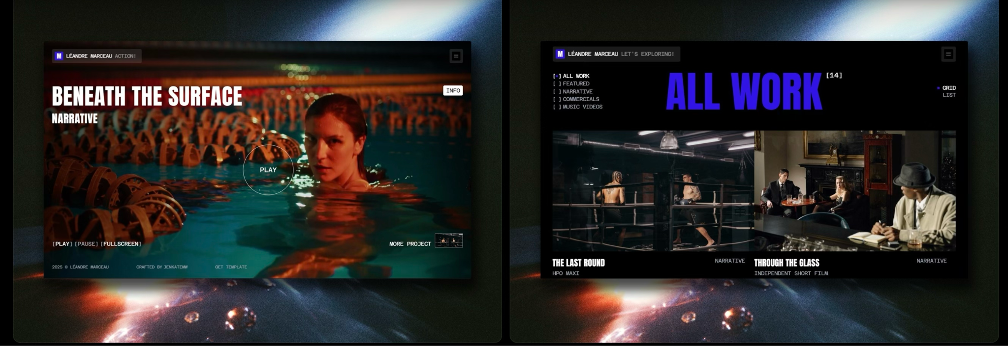
WHY: Artsy, film d’ateur vibe. Good use of the marketing tools we produce
https://www.framer.com/marketplace/templates/linkwoods/
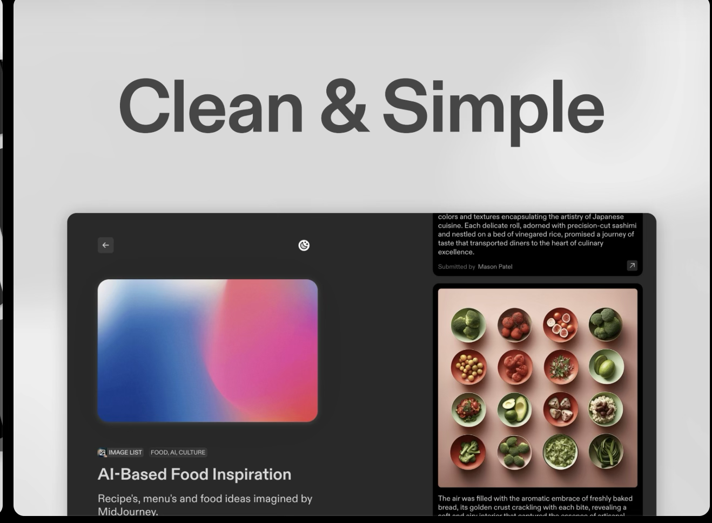
WHY: simple, symmetric, organized. B2B vibes.
https://www.framer.com/marketplace/templates/olliestudio/
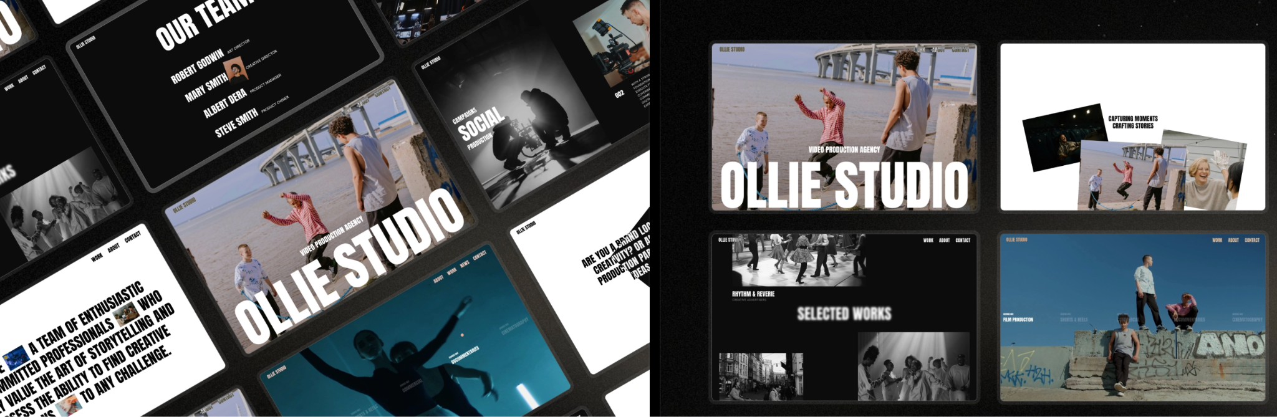
WHY: Hipster, modern but still prioritising content
AI SUGGEST:
Collective — Curation Directory / Catalogue-Style Template
- Built for curation / directory websites: has category pages, filters, CMS-based structure for many items. framer.com
- Perfect if you want to publish your catalogue online: each film as an entry, with metadata, filter by genre, year, rights status, etc.
- SEO-ready, good performance, and scalable — helpful if your catalogue keeps growing. framer.com
✅ Why it works for LB: Because you have a large and growing catalogue of shorts/compilations — Collective lets you present it professionally to partners, filmmakers, and buyers.

https://www.framer.com/marketplace/templates/nexa/
Agel — Agency / Business Portfolio Template
- Designed for agencies / creative businesses — clean, modern, professional. framer.com
- Great for showcasing your services (licensing, distribution), your catalogues, team, contact form, etc.
- Fully responsive and easy to customize — good for filmmakers, distributors, buyers who visit your website. framer.com
✅ Why it works for LB: you’re not just a “portfolio of films”: you offer a service — licensing, curation, global distribution. Agel gives that “digital agency / company” aestheti

